**Git evaluation project**

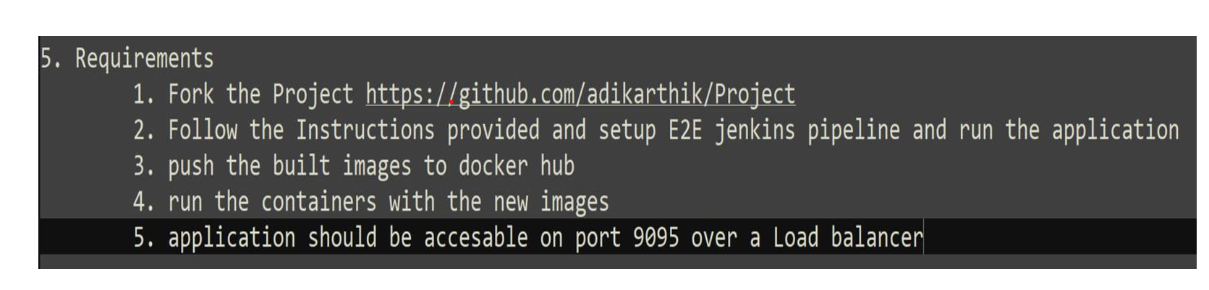

**Git pipeline script**

pipeline {

agent any

environment {

DOCKER_IMAGE = 'iranna730/projectdemo' // Replace with your Docker Hub repo name

DOCKER_TAG = 'latest' // You can set this to dynamic values like ${env.BUILD_NUMBER}

}

stages {

stage('Checkout') {

steps {

// Clone the Git repository

git branch: 'main', url: 'https://github.com/iranna9427/Project'

}

}

stage('Build') {

steps {

// Run Maven build

sh 'cd frontend'

sh 'mvn clean install -DskipTests=true'

}

}

stage('Build2') {

steps {

// Run Maven build

sh 'cd backend'

sh 'mvn clean install -DskipTests=true'

}

}

stage('Build Docker Image frontend') {

steps {

script {

// Build the Docker image

sh "docker build -t ${DOCKER_IMAGE}:${DOCKER_TAG} ./frontend"

}

}

}

stage('Build Docker Image for backend') {

steps {

script {

// Build the Docker image

sh "docker build -t ${DOCKER_IMAGE}:${DOCKER_TAG} ./backend"

}

}

}

stage('Login to Docker Hub') {

steps {

script {

// Login to Docker Hub using credentials

withCredentials([usernamePassword(credentialsId: 'docker-hub-creds', usernameVariable: 'DOCKER_USER', passwordVariable: 'DOCKER_PASS')]) {

sh 'echo $DOCKER_PASS | docker login -u $DOCKER_USER --password-stdin'

}

}

}

}

stage('Push Docker Image') {

steps {

script {

// Push the Docker image to Docker Hub

sh "docker push ${DOCKER_IMAGE}:${DOCKER_TAG}"

}

}

}

}

}

**Console output success**

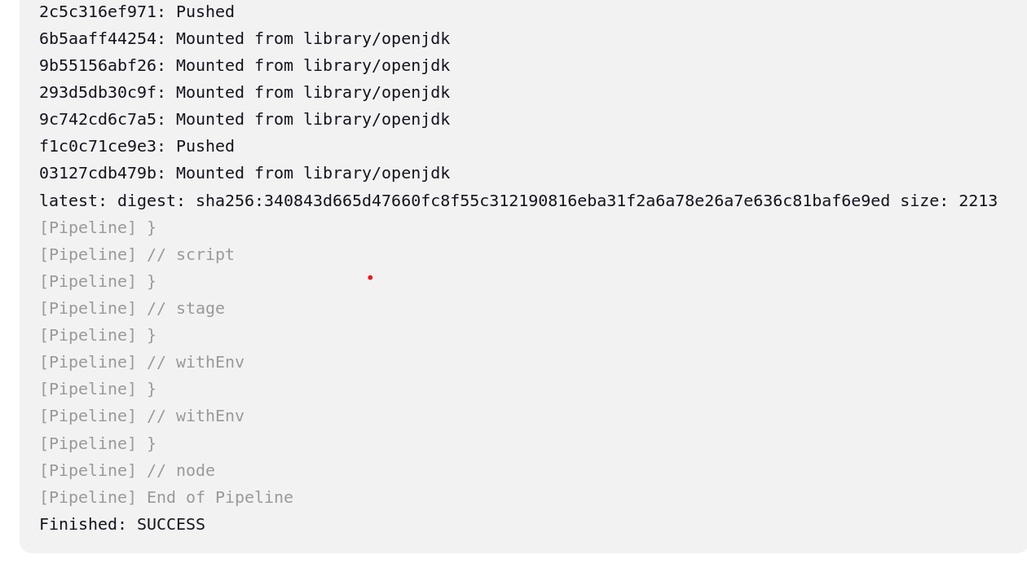

**Docker images created**

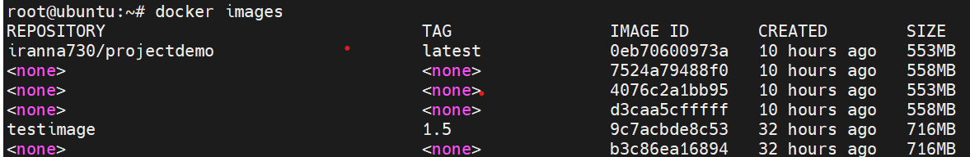

**Docker container Ran on port 9095**

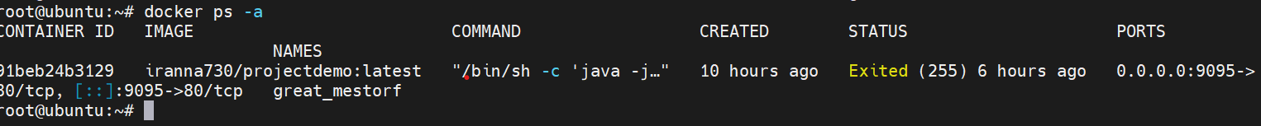

**Image pushed to Dockerhub**

